MIDWEST PHYSICIANS COPY SOLUTIONS
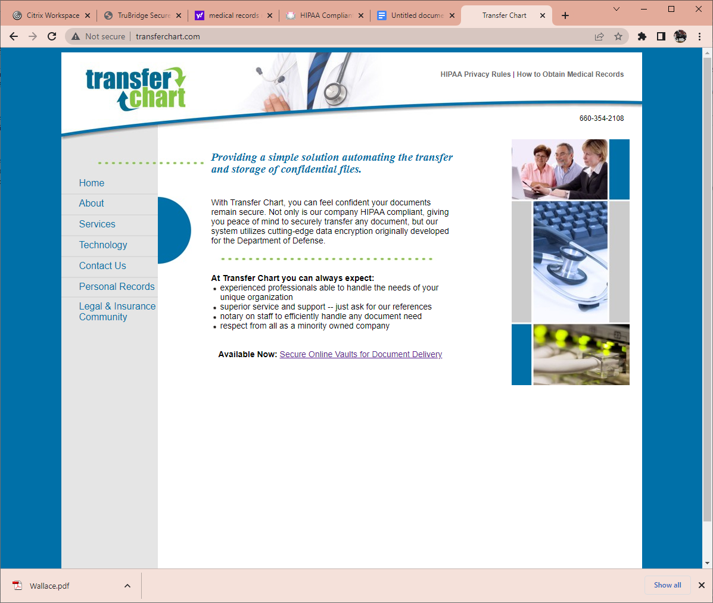
PO Box 234 Polo, MO 64671
660-354-2108 phone
660-354-2166 fax
sales@transferchart.com
www.transferchart.com

1. This form, when signed, will authorize Midwest Physicians Copy Solutions, Transfer Chart to disclose specified protected health/billing information about the person named below.

2. Patient Name:______________________________ Date of Birth:________________

3. Records requested from (Doctor,Clinic,Hospital name):________________________

4. Date(s) of service to be included:_________________________________________

5. Records requested:____________________________________________________
Provide specific records (for example, Left Hip) or check the following: ALL

6. Who are records being shared with?(Check one) Doctor. Lawyer. Self.
Name:__________________________________________________
Address:________________________________________________
Phone #:_____________________Fax #:______________________
Email address____________________________________________

7. How would you like these records sent?(Check one) Mail. Email. Fax.

8. I acknowledge the following statements:
*I understand that Midwest Physicians Copy Solutions, (DBA) Transfer Chart, will charge patients/lawyers (all establishments other than continuing care doctors/clinics/medical professionals) a CHARGE FOR THIS COPYING SERVICE. Price is based on the Missouri Department of Health and Senior Services fee schedule.
* I understand that if I revoke this authorization it must be done in writing.
* Unless otherwise revoked this authorization will expire 60 days from the date signed.
*If I have questions about disclosure of my health information, I can contact the authorized individual or organization making disclosure.
*I understand that the information disclosed pursuant to this authorization may be subject to re-disclosure by the recipient because it may no longer be protected by federal privacy regulations.
*This authorization is voluntary, and I may refuse to sign this authorization.

9. Signature:________________________________ Date:_________________
Electronic signature/date are accepted

Patients representative (print):___________________Relationship:_____________
Patient’s representative must have legal documentation that authorizes them to act on the patient’s behalf.

